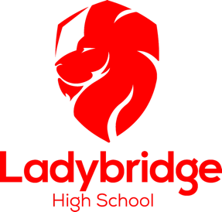
Uniform Policy 2025-2026
Compulsory:
- School blazer (either a branded blazer or a non-branded blazer with an iron on logo) OR Ladybridge branded jumper (NOT sweatshirts or hooded tops)
- School Family Tie (available from retailers after Transition Day)
- White shirt (must be tucked in)
- Choice of plain black trousers, tailored skirt (modest length)* or tailored shorts (knee length) - non-branded items are acceptable
- Black socks (standard length or knee length)
- All black footwear – including all black trainers (must be all black – no coloured logos)
- A bag to carry books and stationery
*Stretch miniskirts (‘pencil skirts’) are not allowed.
Optional:
- Clear nail varnish only*
*Makeup, false eyelashes and acrylic nails are not allowed.
Own Choice:
- Hairstyle, colour and length of hair
- Jewellery (although necklaces must not be visible, and piercings must be small studs only for health and safety reasons*)
- Head scarves (choice of colour and design)
*Piercings must be removed for PE lessons. New piercings must be covered by tape or plasters.
PE Uniform:
- Girls: Ladybridge polo shirt
- Boys: Ladybridge polo shirt and rugby shirt
- Ladybridge hooded top (optional)
- Choice of black shorts or black leggings/Ladybridge branded sports leggings.
- Black socks
- Trainers (not pumps)
- Moulded or screw-in stud football boots
- Hair bobble (learners are required to tie hair back for Health and Safety purposes)
- Swimming cap and one-piece black swimming costume or shorts or trunks
Additional Points:
- Skirts and trousers no longer need to be branded.

Mobile Phones:
Mobile phones are not allowed to be used in school, unless a member of staff has given permission for the phone to be used.

